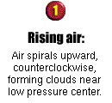
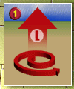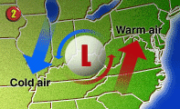
Source: USA TODAY research by Chad Palmer, Graphic by Kevin A. Kepple
How low pressure systems affect weather
By Chad Palmer, USATODAY.com
When forecasters say a low pressure area or storm is moving toward your region, this usually means cloudy weather and precipitation are on the way
Low pressure systems have different intensities with some producing a gentle rain while others produce hurricane force winds and a massive deluge.
The centers of all storms are areas of low air pressure.
Air rises near low pressure areas. As air rises, it cools and often condenses into clouds and precipitation.
If the low pressure area is the center of a Northern Hemisphere extratropical storm, a steady rain or snow can fall to the north of the warm front as warm moist air from the south rises up and over the cold air ahead of the warm front. Showers and thunderstorms often fire up ahead of the cold front in the warm, unstable air.
Usually, showers and thunderstorms ahead of the cold front don't last a long as the precipitation ahead of the warm front.
Due to the counterclockwise circulation around low pressure areas in the Northern Hemisphere, cold air will likely be found to the north and west of low pressure areas while warm air is most often found to the south and east of low pressure areas.

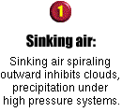
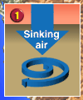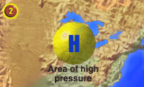
Source: USA TODAY research by Chad Palmer, Graphic by Kevin A. Kepple
High-pressure system brings sunny days
By Chad Palmer, USATODAY.com
Often, you hear a weather forecaster say that an area of high pressure will dominate the weather.
This usually means your region has several partly to mostly sunny days in store with little or no precipitation. Air tends to sink near high-pressure centers, which inhibits precipitation and cloud formation. This is why high-pressure systems tend to bring bright, sunny days with calm weather.
Air flows clockwise around a high-pressure system in the northern hemisphere.
As a result, regions to the east of a high-pressure center often have northerly winds bringing in relatively cold air while regions to the west have southerly winds bringing in relatively warm air.
Sometimes, high-pressure systems stall over a particular region for long periods of time and bring several days of sunny, calm weather with little or no precipitation.
High pressure systems usually form where the air converges aloft. As the air converges in the upper-levels of the atmosphere, it forms an area of higher pressure and is forced to sink. The sinking air spirals outward, clockwise in the Northern Hemisphere, counterclockwise south of the Equator.
High pressure systems are steered by upper-level winds much the same way low pressure systems are steered.

